|  |  |
| --- | --- |
| Contents | Page number |
| 1. Introduction |  |
| 1. Sketches of the WebPages  * Index page(Homepage) sketches * Bio page sketches * CV page sketches * Contact page sketches |
| 2.Wireframes of the WebPages   * Index page wireframe * Bio page wireframe * CV page wireframe * Contact page wireframe |
| 1. Progression of the working |

Introduction

With regard to the main purpose of “Assignment 1: Simple CV Portfolio” (CSY1018) which are:

1. Create your own personal portfolio in order to support your employability
2. Work with HTML5 and CSS,

The report is comprised of the main developmental structure and their overall changes throughout the making of my portfolio.

Rather than jumping into the making of my design decisions and starting off with the coding part of my portfolio directly, I decided to go step by step. The first step would be to do some research and planning for my portfolio. I gathered some ideas and inspiration from other websites. Some of them are:

The step could assist me to picture how my website should actually be looking like but to be honest this step end up creating complexities for me as the websites were actually designed by the professionals. For a starter choosing to go step by step in a simple way would be best. Thus, I decided to first start with the basic design and build it up.

1. Sketches of the WebPages

* Homepage sketches

My homepage will be simple yet different. Starting with the header, it will include the logo and my full name at its left side and some greetings will also be included. I always loved the idea of hover able dropdown menu that we have in our smart phones. Thus, the header will be hover able, displaying thank you message, which will be replaced by navigation bar in other pages. The footer will simply include some social media linked icons and copyright text. I decided to keep the background of my own picture.

The prime focus goes to the main components (links of the Bio, CV and contact pages). They will be kept inside the DIVs which will be in row and they will be having hover able button like effect when the user places the pointer on them. Right above the DIVs,there will be short introduction of mine and the homepage.

The final design includes the placing of the introduction and the triangular arrangement of DIVs inside another DIV.

* Bio page sketches

The Bio page will have the similar hover able header which displays the navigation bar having the links to (home, CV and contacts) pages in a row. Right below the header, a picture of mine will be added in the middle, following that will be my short biography placed in a DIV. The footer will be similar to that of home page.

* CV page sketches

The header and the footer of the CV page will be similar to that of the bio page; only the link to the CV in the navigation bar will be replaced by bio page link. The different sections i.e. education, experience, courseworks etc. will be placed in 2 columns. Each sections will have its own DIV.

* Contact page sketches

The navigation bar will have the link to the home, bio and CV pages. The header and footer will have no change. The page will have a form and a DIV including the contact details where some icons will also be considered.

Wireframes of the WebPages

* Index page Wireframe

Header (Hover able)

[Greetings]

(Hidden message)

(Hidden message)

Main DIV

Small introduction

Equal sized DIV1

Equal sized DIV2

Equal sized DIV3

Footer

Icons

1. Bio page wireframe

My picture

DIV

Short biography

Footer

Header (Hover able)

Navigation bar (hidden)

1. CV page wireframe

Navigation Bar (hidden)

Header (Hover able)

Footer

DIV

(Section)

DIV

(Section)

DIV

(Section)

My picture

DIV

(Section)

DIV

(Section)

Full name &

Contact details

1. Contact page Wireframe

Footer

DIV

Contact details

Form

Navigation bar (hidden)

Header

Progression of the website

1. 1-4 weeks

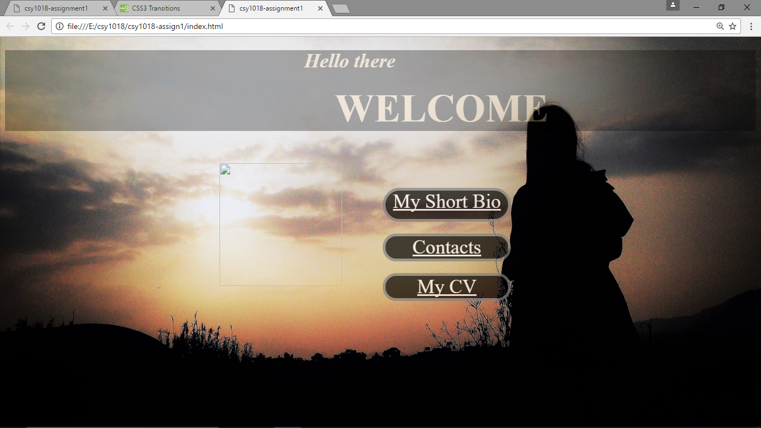

Fig 1. First 2 weeks of working on Homepage

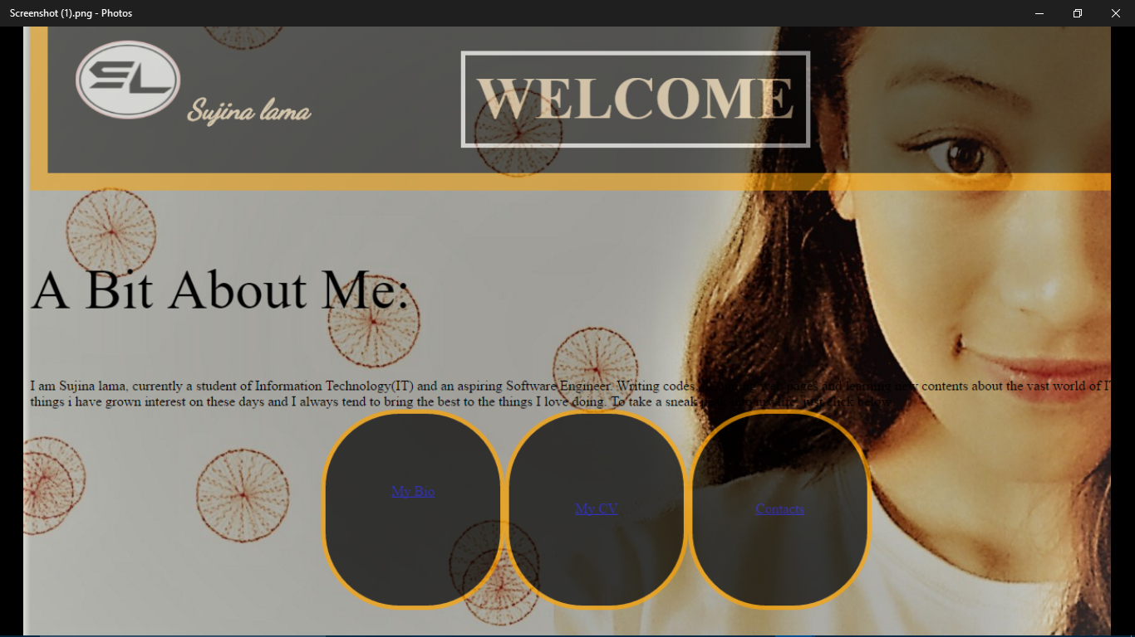

Fig 2. Last 2 weeks of a month on Homepage

I started my working from the designing of the Index page. I decided to create the header and the DIVs first. The first picture represents my webpage after 2 weeks of working where it can clearly be seen that the header is simple and the DIVs are also not placed in its position as planned. The DIVs contains the links to the Bio, CV and contact pages respectively.

The second picture represents the webpage after another 2 weeks of my working. I mainly worked on its CSS where in header; I placed the logo at its left with my full name after providing it an orange border. The ‘Welcome’ text was given a white border after placing it in the separate DIV. Flex property has also been used; DIVs containing links have been arranged in a row. A short introductory part has also been added above the DIVs and the background image is also changed. Overall, drastic changes have been made.

1. 4-8 weeks

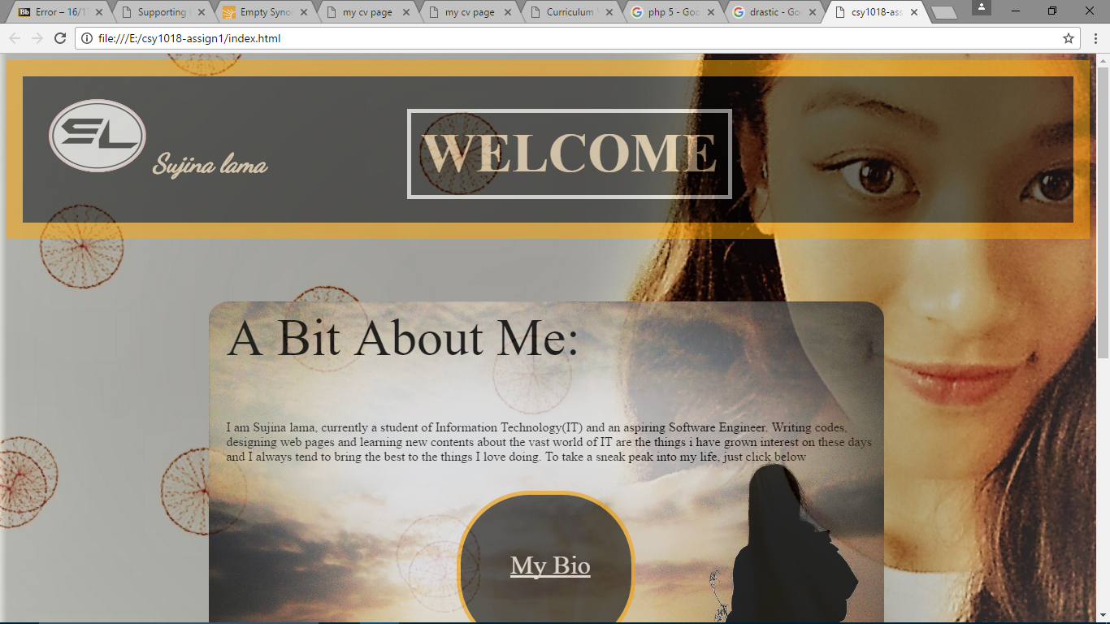

During 4-6 weeks, I continued my working on my homepage, as you can see there is no change in the header but the short introductory part and the DIVs are placed inside another DIV which is placed right in the middle of the webpage which was achieved after assigning its height, width and padding to it. DIVs, which was previous in a row is changed into the triangular arrangement. The footer having the icons and the copyright text has also been created.

The following is the Bio page that I created during 6-8 weeks. I decided to write the short bio of mine first and kept it inside the DIV and determined its height and width. In its CSS, I used the gradient background. Thus, during these weeks, I made the least progress in the making of my web site.

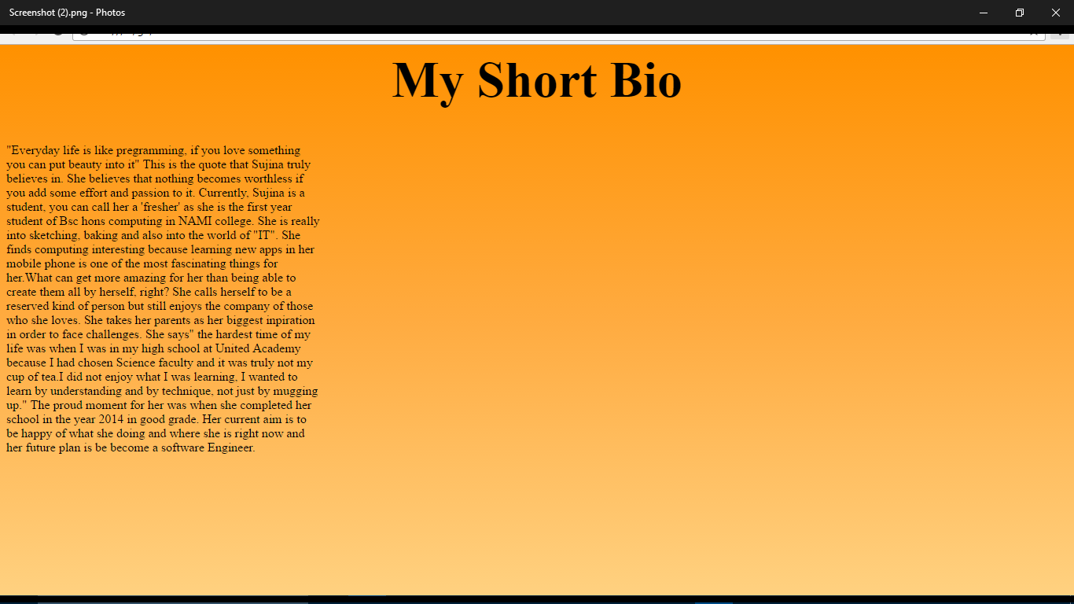

1. 8-12 weeks

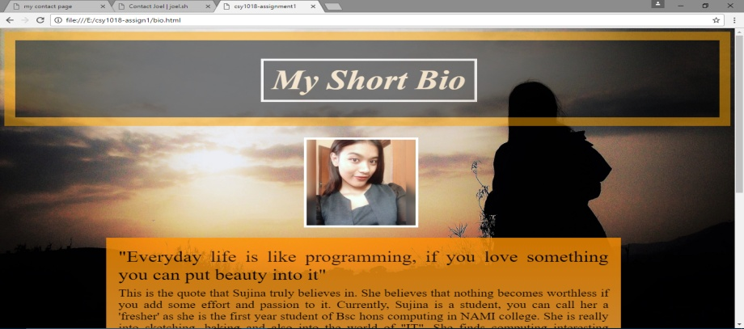

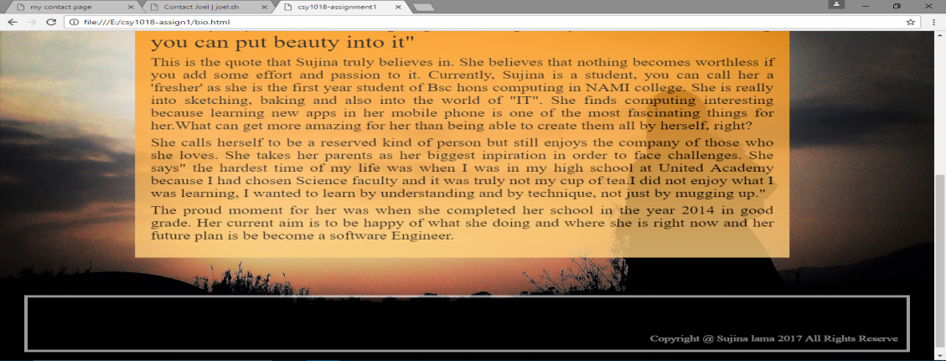

I worked on the CSS of the bio page and added the header and footer along with my photo and DIV containing my short bio. I basically worked with the padding and aligning of the text during my 8th week.

